**If statement**

**Syntax:**

if(condition)

{

// Statements to execute if

// condition is true

}

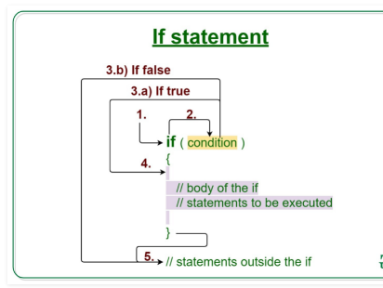

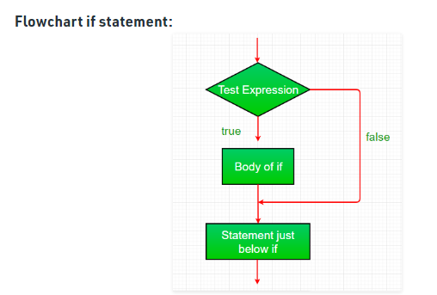

**If else statement**

if (condition)

{

//true block body

}

else

{

// Executes this block if

// condition is false

}

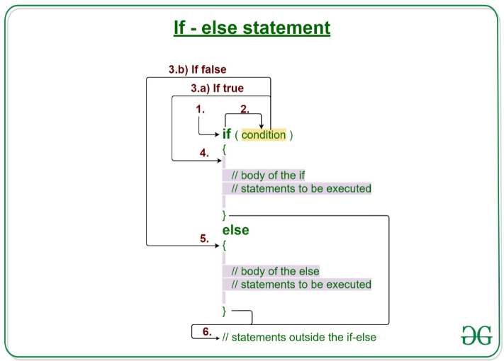

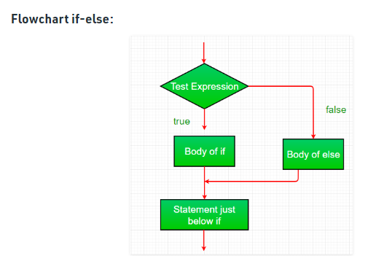

**If-else If-ladder**

**Syntax:**

if (condition)

statement 1;

else if (condition)

statement 2;

.

.

else

statement;

